**Learning Outcomes**

1. Understanding JSON
2. Handling JSON requests
3. Accessing and loading Images from the Internet

**Design**

Copy the design files for the Image Album

**Default Layout**

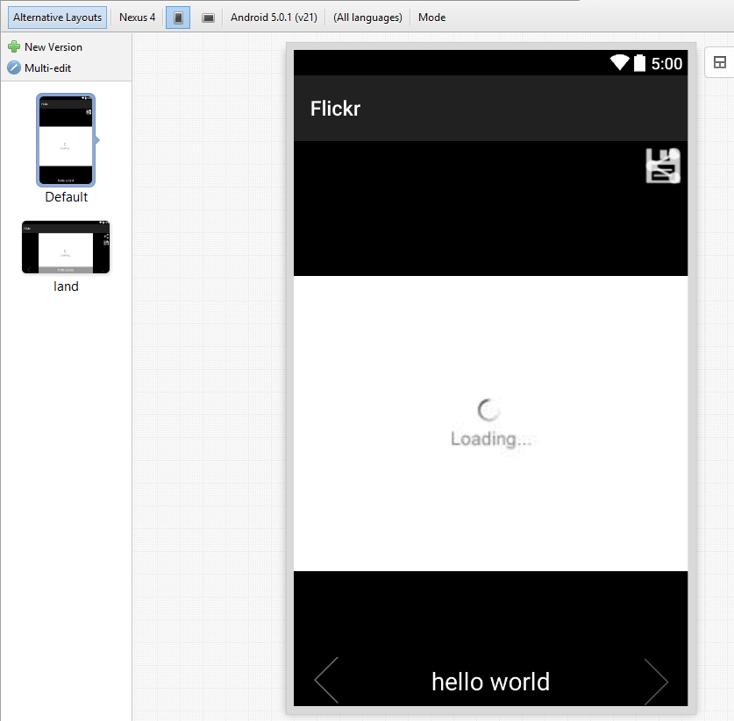

**Landscape mode**

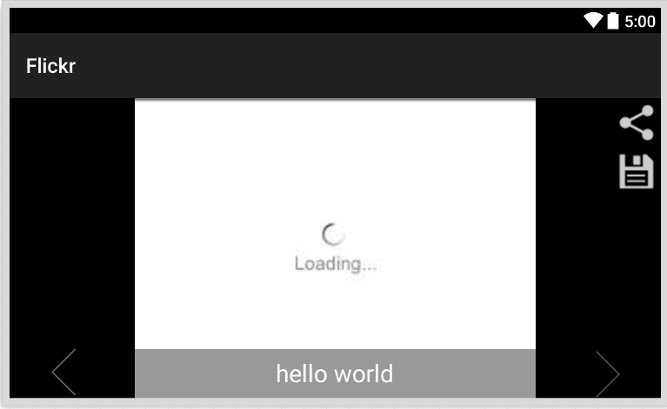

**To have a landscape mode layout**

Create a folder named layout-land

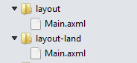

**Changes to MainActivity.cs**

To set the screen orientation to landscape set the screen orientation attribute in the Activity Label. 

**Flickr Interestingness API**

Browse to the Flickr API

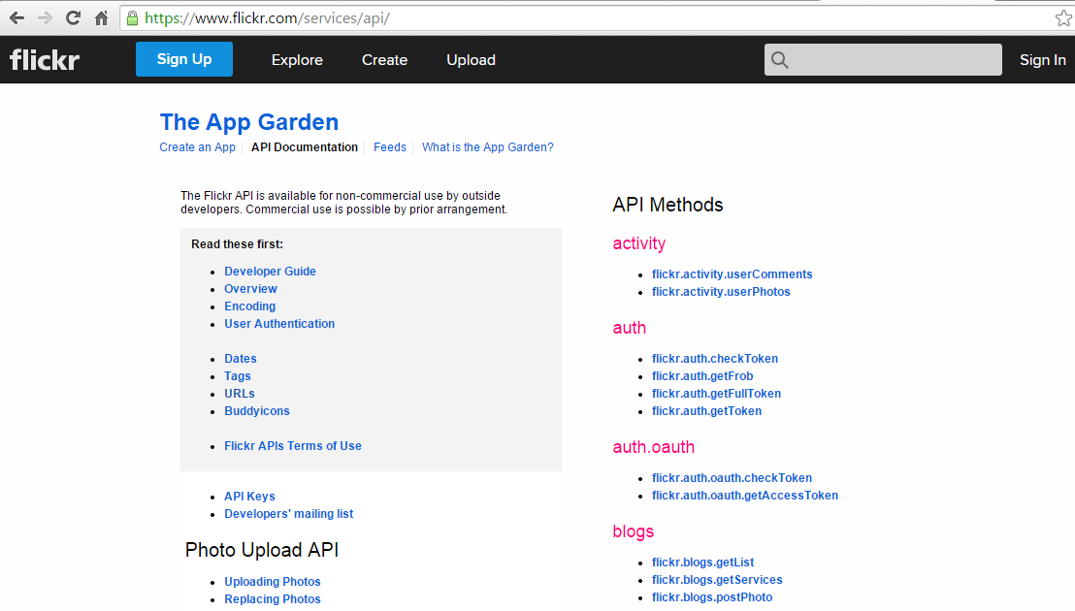

Find the Interstingness API

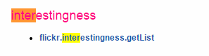

Click on the API explorer link

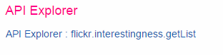

Change the output method to JSON and click Call Method

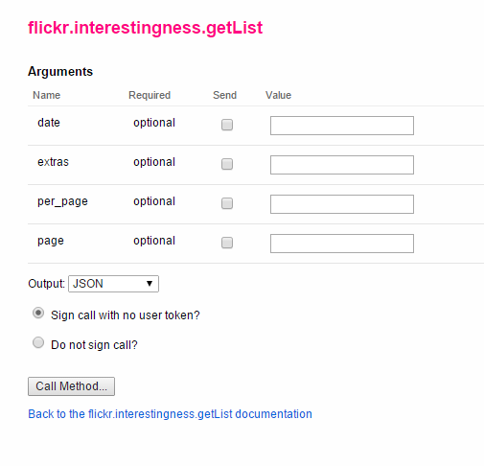

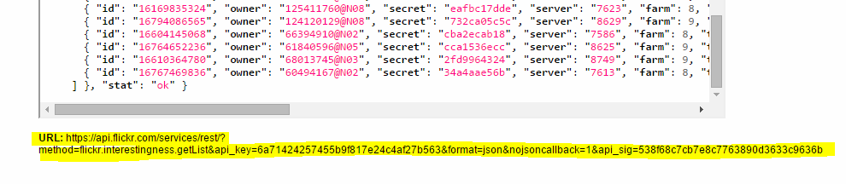

Copy the URL in a text editor.

You will need the URL, API_key, API_Sig, and format.

Read the API documentation about accessing an Image through JSON object.

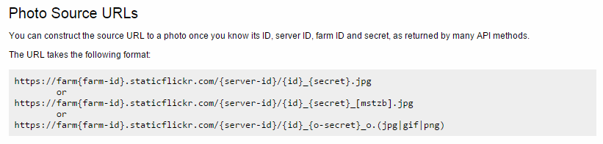

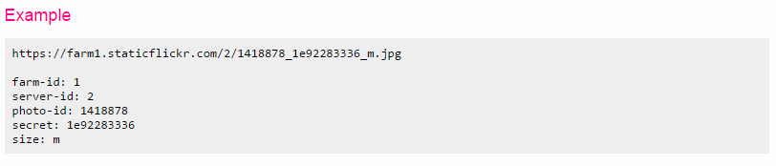

**JSON Object**

JSON: JavaScript Object Notation.

JSON is a syntax for storing and exchanging data.

JSON is an easier-to-use alternative to XML.

The following JSON example defines an employees object, with an array of 3 employee records:

JSON Example

{"employees":[  
    {"firstName":"John", "lastName":"Doe"},   
    {"firstName":"Anna", "lastName":"Smith"},  
    {"firstName":"Peter", "lastName":"Jones"}  
]}

The following XML example also defines an employees object with 3 employee records:

XML Example

<employees>  
    <employee>  
        <firstName>John</firstName> <lastName>Doe</lastName>  
    </employee>  
    <employee>  
        <firstName>Anna</firstName> <lastName>Smith</lastName>  
    </employee>  
    <employee>  
        <firstName>Peter</firstName> <lastName>Jones</lastName>  
    </employee>  
</employees>

**JSON Response obtained from Flickr**

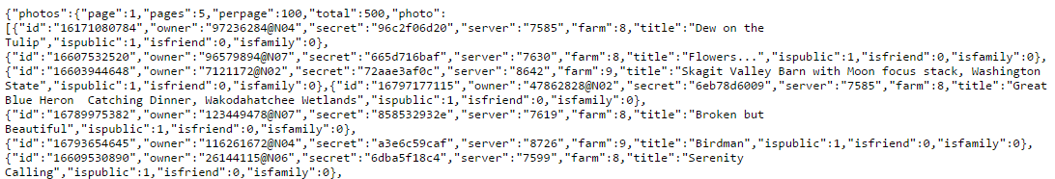

**De-serializing JSON using Newtonsoft.JSON**

1. Create a class from the JSON response and generate your C# class

Go to http://json2csharp.com/

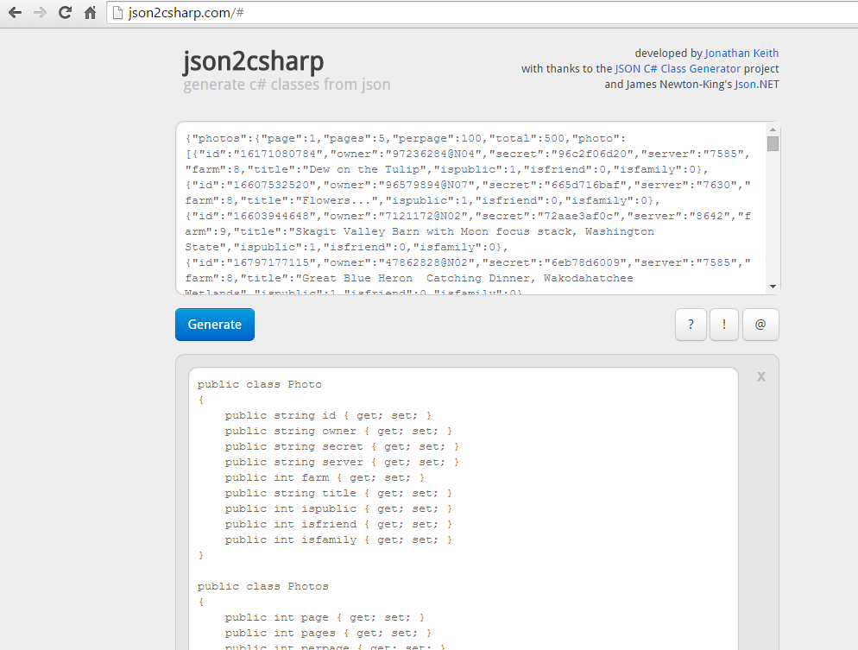

1. Add a new class name it Response.cs

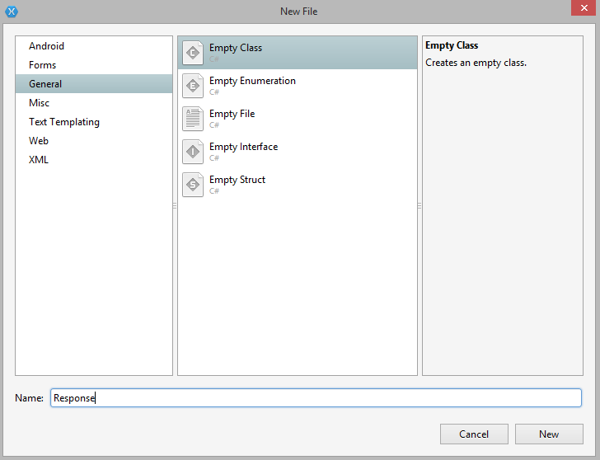

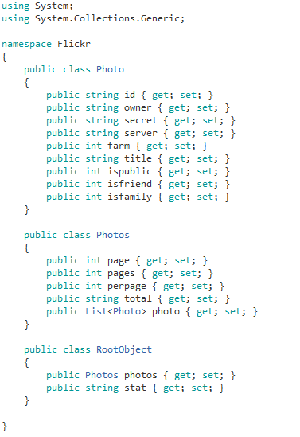

1. Adding NewtonSoft.JSON package

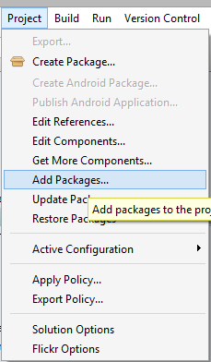

Search for JSON.Net and click on Add Package.

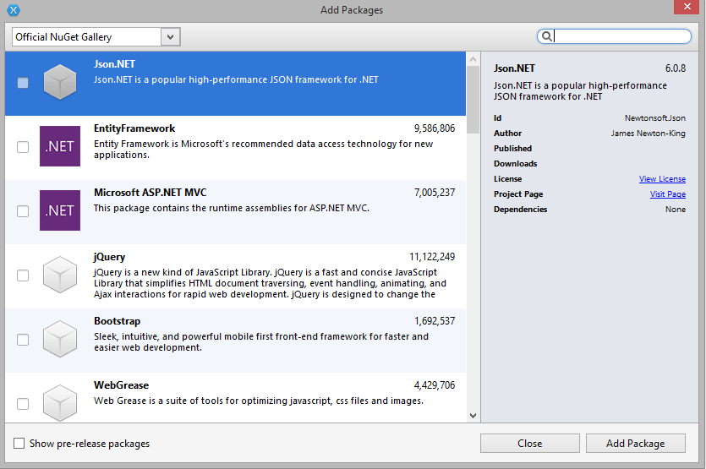



1. Add the Components RestSharp and Image View Helper from the Component Store

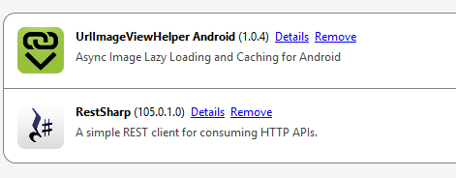



JsonConvert.DeserializeObject helps to deserialize the JSON response to a C# object.

**RESTHandler.cs**

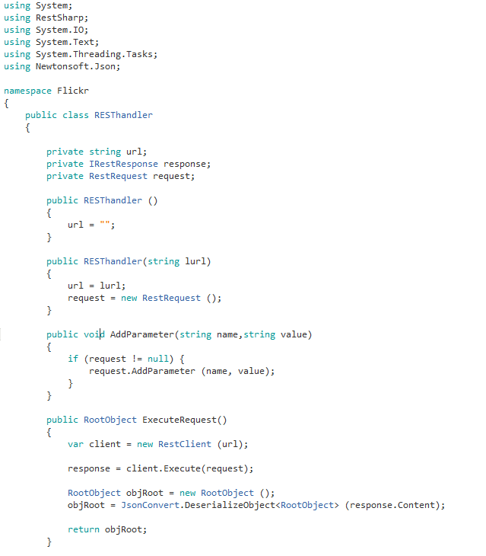

**Async** version of JSON deserialization

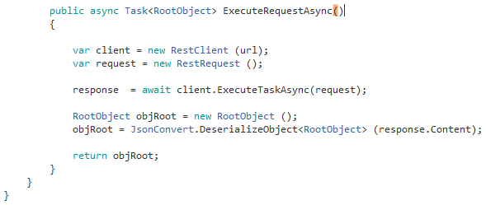

**MainActivity.cs**

Initialize the controls, RESThandler and Response objects

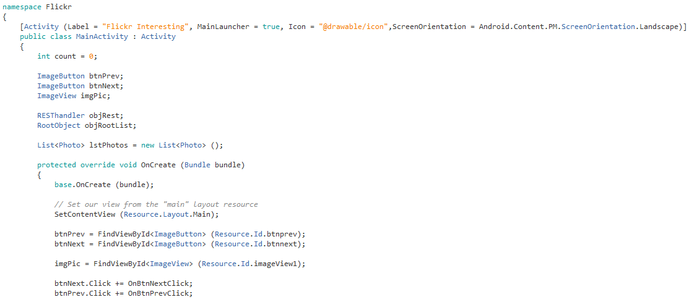

Form the API request, modify the api key and api signature to the one latest obtained from Flickr.

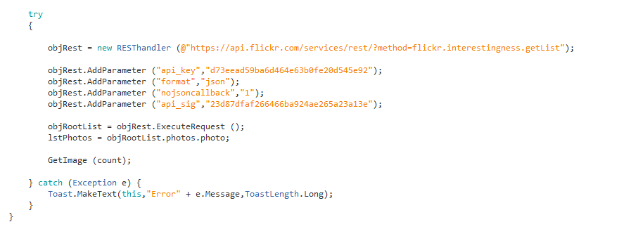

The **GetImage()** function

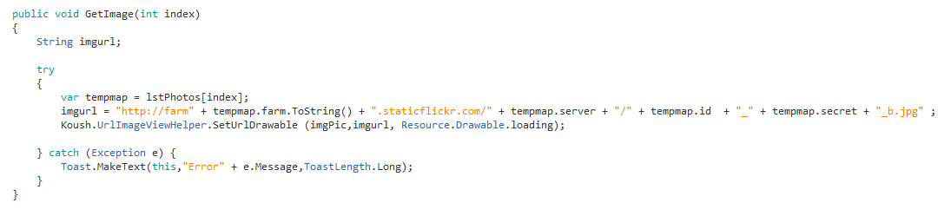

The Next and previous button click

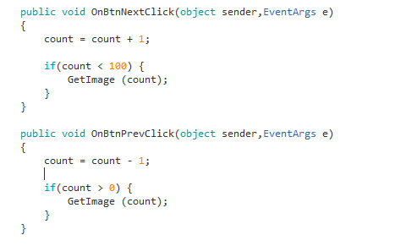

**Exercise**

Implement the save and share functionality for the FlickR image album